**PARCIAL 1**

**ANGELA AGUILA 4-818-1362**

**PROBLEMA 1:** DIAGRAMA DE ENERGÍA

Construya un diagrama de energía vs ángulo de enlace para el 2,3-diclorobutano

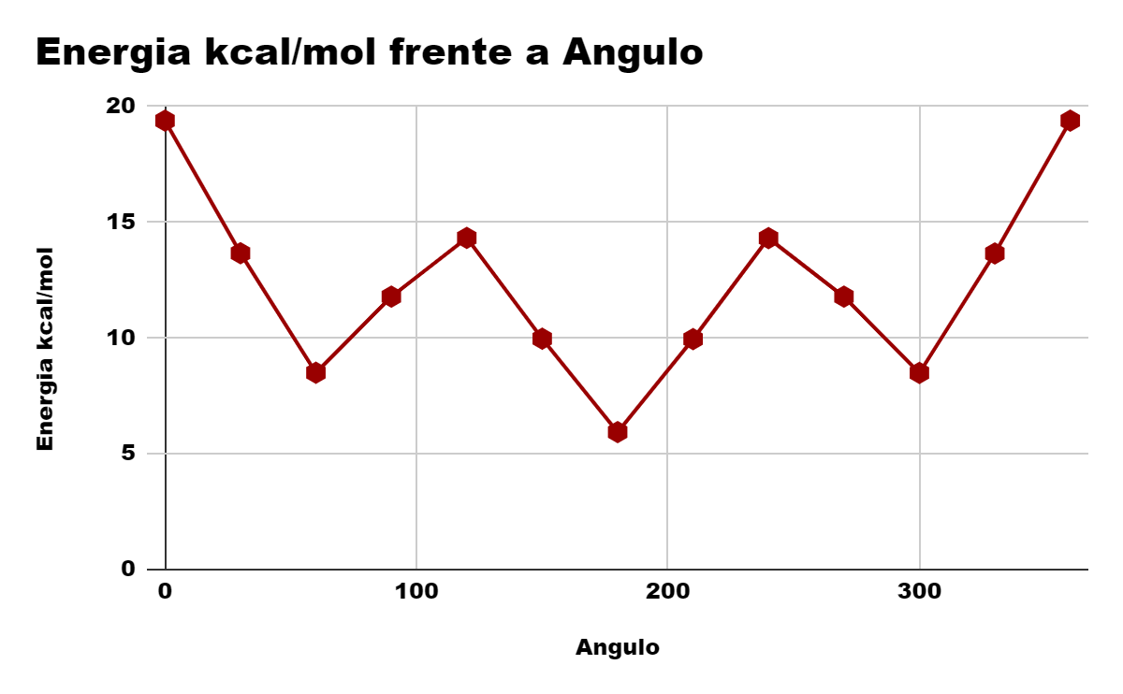

| **Angulo** | **Energia kcal/mol** |
| --- | --- |
| **0** | **19,388** |
| **30** | **13,661** |
| **60** | **8,499** |
| **90** | **11,786** |
| **120** | **14,323** |
| **150** | **9,969** |
| **180** | **5,935** |
| **210** | **9,951** |
| **240** | **14,313** |
| **270** | **11,786** |
| **300** | **8,491** |
| **330** | **13,651** |
| **360** | **19,388** |